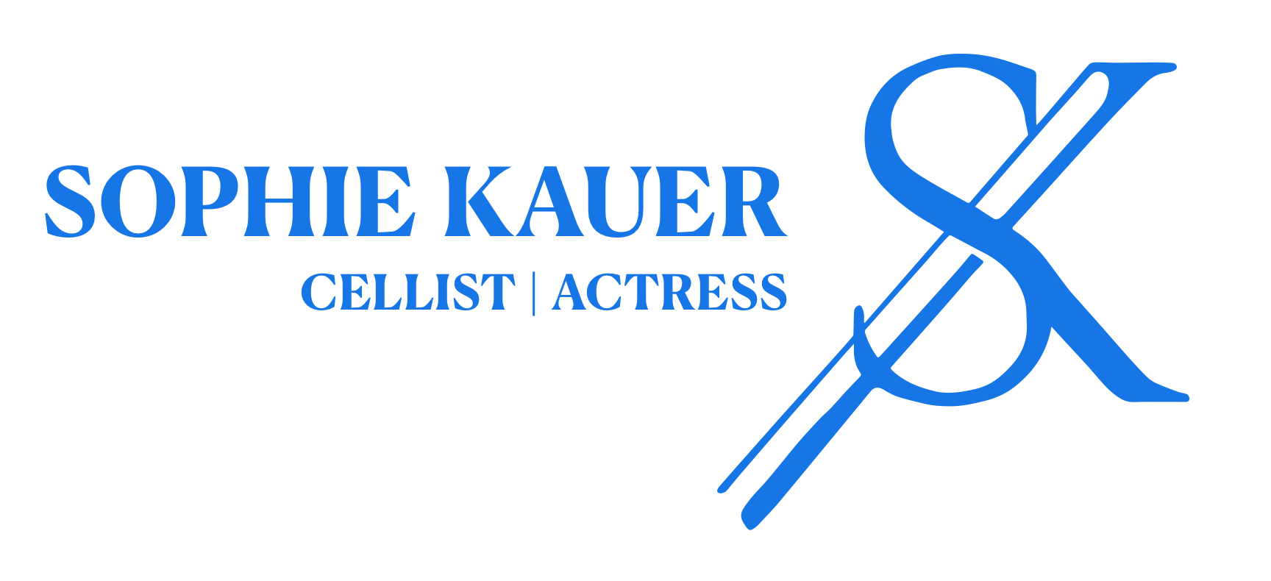
Sophie Kauer is a British-German cellist and actress known for putting herself at the forefront of evolving classical music and the way we see it (Herbert Music). Hailed by the Times as a prodigious talent that could blossom in any direction she chooses and by renowned composer John Williams as an extraordinary actor and consummate musician, her cello playing is characterised by the beautiful, sensual depths of its tone (Die Zeit), and impeccable technique and deep musicality (Richard Balcombe).

Sophie’s breakthrough came with a leading role in Todd Field’s feature film TÁR, starring Cate Blanchett, where her performance was praised as a standout (The Face), scene-stealing (Variety) and star-making (TotalFilm) and won her a Best Supporting Actress award. Sophie played live in the film alongside the Dresdner Philharmonie, with her solos from the Elgar Cello Concerto receiving critical acclaim from Leonard Slatkin and the Telegraph. She later recorded music for the soundtrack album with the London Symphony Orchestra - released by Deutsche Grammophon, it went to No.1 in the US Classical Billboard chart.
​
Kauer has achieved remarkable early success in her musical career. Her debut EP, Unsung (Deutsche Grammophon) made her the youngest artist to reach No. 1 on the Classical On-Demand Audio Streaming Chart. She is a Classic FM ‘Rising Star,’ has been nominated for an Opus Klassik Award, and was chosen by the Times as the Classical Breakthrough nominee for the 2023 South Bank Sky Arts Awards. She was named ‘One to Watch’ by People Magazine and a ‘Rising Star of Stage and Screen for 2023’ by the Evening Standard.

Past seasons have seen Sophie perform as a soloist with a number of world-renowned orchestras such as the Deutsches Symphonie Orchester, Düsseldorfer Symphoniker, and Gewandhaus Orchester. Recent festival highlights include the Bach300 Festival in Leipzig alongside Lang Lang and Daniel Hope (broadcast on ARTE), Festspillene in Bergen, Oslo Kammermusikkfestival and solo/chamber recitals across Europe, such as at Aula Seriene or Oslo Konserthus. Committed to supporting underrepresented voices in classical music, Sophie has commissioned new works from female composers to premiere, and co-organized a festival celebrating them at the Norwegian Academy of Music.
​
Born in London in 2001, to a British-German family, Sophie began playing the cello aged 8. Just 18 months later, she was accepted into the Junior Department of the Royal Academy of Music where she held a scholarship and of which she is now an associate (ARAM). From 13 to 18 years old she was also a private student of distinguished cello professor, Melissa Phelps and leading collaborative pianist and coach Alison Rhind. She continued her studies at the Norwegian Academy of Music under world-renowned cellist Torleif Thedeén, where she also received contemporary music coaching from Peter Herresthal and duo coaching from Per Lundberg.
​
Beyond her musical achievements, Sophie is an ambassador for the ‘Cheryl King Trust’, a charity dedicated to funding music tuition for financially disadvantaged children. She is supported by Talent Norge’s ‘Podium’ programme, a new talent scheme for emerging soloists. She is a ‘Royal Philharmonic Society’s Julius Isserlis Scholarship’ and ‘Tom Wilhelmsens Stiftelse Award’ recipient and a ‘Dextra Musica Artist’.

Her media presence is extensive, with performances and interviews featured on BBC Radio 3, ZDF, RBB, ClassicFM and numerous international print and broadcast media outlets, including the Times, Telegraph, New York Times, Die Zeit, Arte Magazin, Aftenposten, Gramophone, Strad, The Face, BBC News, Evening Standard, SWR3, TV4, BR-Klassik, Deutschlandfunk Kultur, Sveriges Radio and NRK radio.

Sophie plays a Thomas Meuwissen cello kindly loaned to her through Dextra Musica.
​

For inquiries, please email contact@sophiekauer.com
© Sophie Kauer, 2025 / Not to be altered without permission.
www.sophiekauer.com​

